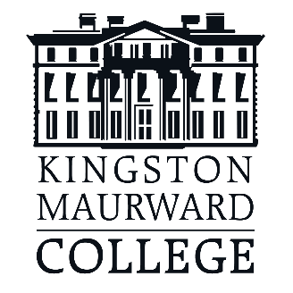
Full Name Age
Course
College email address
Contact number
What days are you in College and working from home?
Which roles are you applying for?
Please state why you want to apply for this role.
In your role, how would you help students?
What personal qualities would you need for this role?
Kingston Maurward College
Students’ Union Officer
If you would be interested in becoming an SU Officer, please
complete the below form and email it to su.rep@kmc.ac.uk

